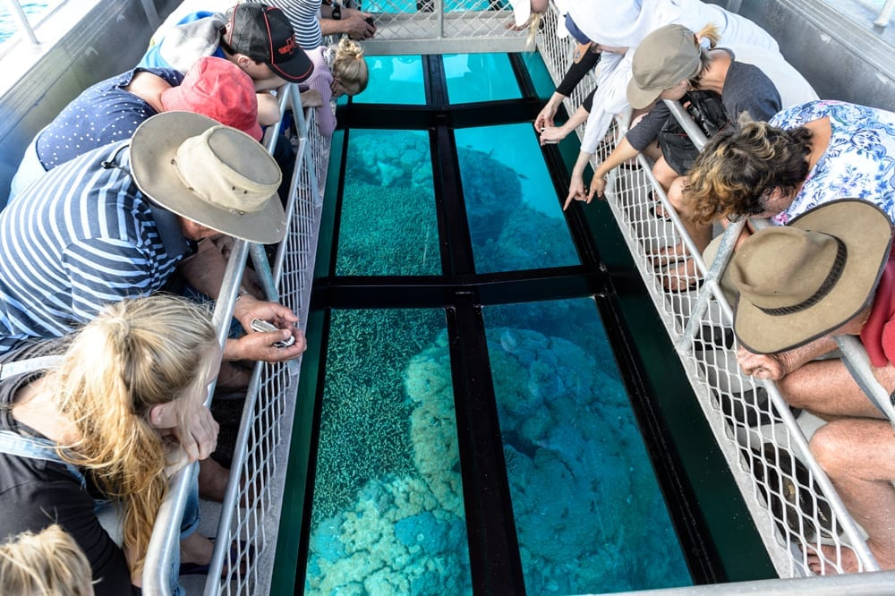
Penny King -Director
PH: 0433 255 472
Tours For Women
Norfolk Island Tour
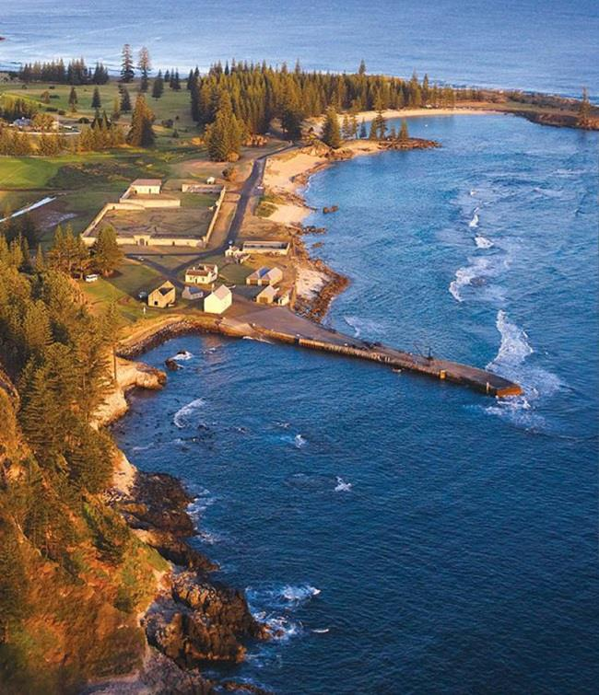
Tours For Women
Norfolk Island Tour
10 days/9 nights

Date | Time | Program
Saturday  30 April | TBA | Passengers depart Adelaide  Arrive Sydney Domestic  Accommodation in Sydney  Dinner with a view! Let’s make the most of Sydney!
Sunday  1 May | 9:30 am | Depart Sydney International terminal QF0179
 | 1:10 pm | Arrive Norfolk Island  Check in to our Paradise Hotel & Resort – double Garden room
 | 6:30 pm | Welcome  Dinner at Hilli’s Restaurant  (Short walk across the road)
Monday  2 May | Morning | Cooked Breakfast at hotel
 | 9:00 am | Half Day Island Orientation Tour  With morning tea
 |  | Free Time for relaxing and exploring
 | 7.30pm | Dinner – out and about
Tuesday  3 May | Morning | Cooked Breakfast at hotel
 | 9:00 am | Island Adventure 4WD Tour  A 3hour tour taking in the varied landscapes of the island – including the Boobook Owls!
 | 1:30 pm | Colleen McCullough Home Tour  Visit the author’s home and learn more about her life here, as well as remembering some of her great stories.
 | 6:15 pm…. | Bounty Bar & Grill (special)  2 course dinner
Wednesday  4 May | Morning | Cooked Breakfast at hotel
 |  | Free Time for relaxing and exploring
 | 1:30 pm | Pitcairn Settlers Village: The Bailey historic homestead & gardens, the forge, a museum, film of the ‘Pitcairn story’ and morning tea!
 | 4:45 pm  7.00pm | “Trial of the Fifteen” play - courtroom drama with many of the stories from the island’s past.  Dinner to follow
Thursday  5 May | Morning | Cooked Breakfast at hotel
 | 8:30 am | “Over the Cattlestops”  We visit a few of the locally owned businesses that make up our industries. Norfolk Island has a huge number of small businesses making different local products that we can see - and maybe have a taste of! We will also enjoy morning tea at a beautiful scenic location.
 |  | Free Time for relaxing and exploring
 | 4:45 pm | Island Fish Fry (a ‘fry-up’!)  Sunset dinner with dancing and singing  BYO drinks …. We’ll organise on the way!
Friday 6 May | Morning | Cooked Breakfast at hotel
 |  | Free Time for relaxing and exploring
 | 1:00 pm | Curious Castaways  A story of English Pirates & Polynesian Princesses. Tour includes fascinating early Pitcairner history, Norf’k language, weaving and wetls/traditional food tasting. All Including afternoon tea
 | 7.00pm | Dinner together…
Saturday 7 May | Morning | Cooked Breakfast at hotel
 |  | Free Time for relaxing and exploring
 | 2:00 pm | Glass Bottom Boat Tour  Your guides: Don & George who are 7th generation descendants of HMAS Bounty. Across the coral reef on a unique boat.
 | 6:15 pm | Ghost Tour Dinner and Lantern Walk  Real ghost stories & real hauntings. Bring an open mind and come beyond the boundaries of the known….  Dinner together will bring us back to the real world!
Sunday 8 May | Morning | Cooked Breakfast at hotel
 | TBA | Sunday Markets  Explore the local markets, a chance to pick up locally made products and listen to local Island entertainers.
 | TBA | Fletcher’s Mutiny Cyclorama Visit  An immense panorama painting in 3D. Amazing!
 | 7.00pm | Dinner together
Monday 9 May | Morning | Cooked Breakfast at hotel
 |  | Free time for a walk or … an extra coffee
 | 2:10 pm | Depart Norfolk Island QF0180
 | 4:00 pm | Arrive Sydney International terminal
 |  | Passengers depart Sydney Domestic Airport
 | Approx. 8pm | Arrive Adelaide Terminal
INCLUDED IN  TOUR | - All Transfers & transport  - Double room, single use  - Breakfast and one other meal each day  - Guided tours / experiences/ activities listed here  - All tips and gratuities  - Entrances to all parks, resorts, etc  - Flights – economy return.  ** A discount of $1250 applies should you wish to travel Business Class or if you book your own flights.
NOT INCLUDED | - Travel Insurance (mandatory) Speak to us.  - Extra luggage costs  - Drinks: eg wine, cocktails, coffee, etc  - Personal expenses eg: laundry
**AND ALSO: | - Only 10 places available on the tour.  - This tour overview is the first of a formal process towards the specific, timed itinerary issued closer to the time.  - Activities and visits will not change though.  - You must be at least ‘double vaxxed’
COST  Per person | Contact us for more information
Tours For Women Director: Penny King

PO Box 589 Walkerville SA5081. PH: 0433 255 472
penny.king@toursforwomen.com.au

Travel Agent Partner Travel master. Director: Jenny Georgieff

2/9 Eurilpa Avenue, Everard Park SA5035. PH: Tel: 0403188091
jenny_tm@internode.on.net

