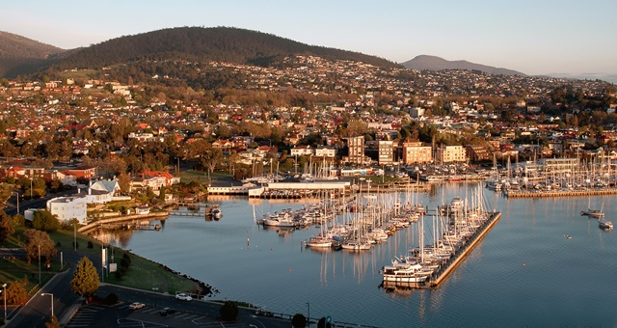

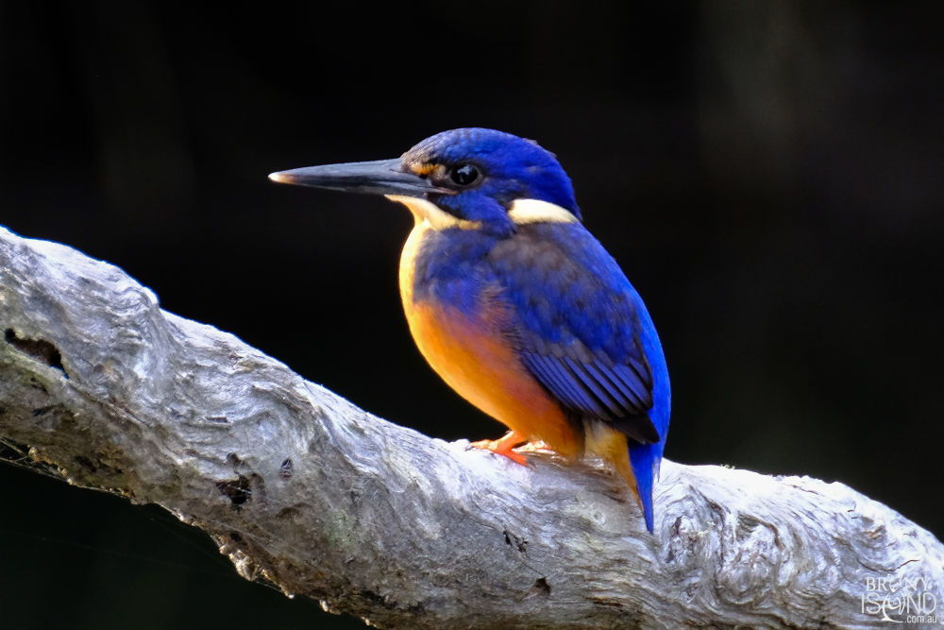

Tours for Women

[www.penny.king@toursforwomen.com.au](http://www.penny.king@toursforwomen.com.au)

M: 0433255472

In partnership with:

Travelmaster Travel Agency

Ph: 08 71271891

***TASMANIA***

**Tours For Women**



**TASMANIA** –13 night tour: \*\**Subject to change*

|  |  |  |
| --- | --- | --- |
| 19 - 22 February 2021 | **Hobart**  ***Hadley’s Orient Hotel***  ***3 nights*** | Salamanca markets  Mt Wellington  Bonorong Devil Sanctuary  Bruny Island: Lighthouse/ Foodie visit  Cascades Female Factory site |
| 22 - 24 February | **Strahan**  ***Motel Strahan***  ***2 nights*** | Drive to Derwent Bridge for lunch  Visit ‘The Wall in the Wilderness’  World Heritage cruise & lunch  Forest walk to Hogarth falls  Cradle Mountain |
| 24 - 27 February | **Launceston**  ***Tasmania Country Club***  ***3 nights*** | Peaceful days of exploring, shopping, lunches…  OR  ‘Let’s do lunch’ - Joseph Chromy wines  Gorge gardens  Tamar Valley Wine Tour  Cheese, wine and cider tastings |
| 27 Feb – 1 March | **Coles Bay**  ***Freycinet Lodge***  ***2 nights*** | Lunch in Bicheno, scenic, historic town.  Wine tastings  Arts, crafts etc  Visit to Ross, historic town |
| 1—4 March | **Hobart**  ***Hadley’s Orient Hotel***  ***3 nights*** | Historic town- Richmond  Port Arthur: Cruise and Visit  MONA visit |
| 4 March | **Hobart Airport:** | Fly Home |

**Tour Inclusions:** your own double room, all activities, transfers, transport, 2 meals/day, guides, entrances, events. **Airfares** - TBA **extra** – approx.: $350 return. We can arrange. **Not included:** all drinks (wines, spirits etc), insurance, personal expenses